Title page

(with the title of your paper at the top)

This first page is formatted differently from the others

When copying text into this file, do not copy any ‘old’ style sheets! To do this, select the ‘Copy text only’ insertion option.

**Shortcuts for the relevant style sheets:**

"Standard" = standard paragraph = Ctrl+Shift+S

"Citation block" = for indented quotations = Ctrl+Shift+Z

"Paragraph after citation" = for standard paragraphs after citations and headings = Ctrl+Shift+A

"Bibliography" = for the bibliography = Ctrl+Shift+B

The "Footnote text" style sheet is available for footnote blocks = Strg+Umschalt+F.

*However*, to insert a footnote, press Ctrl+Shift+Ü.[1]

# "Heading 1" = Ctrl+Shift+1 = first-degree heading (always starts on a new page! If no "Heading 2" follows, keep some distance from the text block)

## "Heading 2" = Ctrl+Shift+2 = second-degree heading (requires 2 empty lines of "standard paragraph" format before it and 1 empty line after it in the running text)

### "Heading 3" = Ctrl+Shift+3 = third-degree heading (requires 1 empty lines of the "standard paragraph" format before it and 1 empty line after it in the running text)

Further chapter differentiations should not be made by "Heading 4", "Heading 5" etc., but by other subordinating clues within a third-degree subchapter.

## Practical procedure

### How to devise your term paper or Bachelor thesis

1. Determine your topic.[2]
2. Derive from the topic: What specific question do I want to answer? Or: What specifically do I want to scrutinise?
3. Derive sub-questions or sub-aspects from the question or the scope of the investigation.
4. Arrange the sub-questions or sub-aspects logically and, in this way, create a (provisional) chapter structure.
5. Search for suitable references for each chapter (especially using library catalogues like [OPAC](https://ub.uni-greifswald.de/) or [GVK](https://gvk.k10plus.de/?COOKIE=U999,K999,D2.1,E3351f5d4-2,I0,B9994++++++,SY,QDEF,A,H12,,73,,76-78,,88-90,NGAST,R95.91.211.64,FN&COOKIE=U999,K999,D2.1,E3351f5d4-2,I0,B9994++++++,SY,QDEF,A,H12,,73,,76-78,,88-90,NGAST,R95.91.211.218,FN), which display accessible titles). This process results in a preliminary bibliography. It is divided into two parts: sources and text editions on the one hand and scholarly literature and academic aids (e.g., encyclopaedias) on the other.
6. Read/scrutinise the sources/editions and check the scholarly texts you are considering in your preliminary bibliography for relevant chapters.
7. Read the respective chapters of relevant scholarly works from the vantage point of your specific research question and interest. Ignore any other information.
8. Start writing chapter by chapter. To write means here to give appropriate answers to your sub-questions or, respectively, a proper investigation of sub-aspects.

### Some other tips

A paper gives you the opportunity to practise under supervision how to write and structure a scholarly text. This includes

1. finding a topic,
2. theoretically analysing the topic,
3. choosing a method, procedure, approach (sometimes only reflecting on a method),
4. collecting material or quotations,
5. clearly identifying research objects and sources,
6. analysing the topic, and
7. concluding with a written presentation. The latter usually means presenting your results and documenting your approach through your paper.

An academic paper should deal with a topic that has not been dealt with before in this form, or it should deal with a known topic in such a way that new findings can be presented. Your term or examination paper may be somewhat more modest and concentrate more on presenting known methods or results. However, it is expected that you show the material from your perspective ('in your own words'), that you find your examples and do not remain uncritical but discuss the pros and cons of the topic, examples, method, findings, or approach.

The topic, the exact objective or problem and the chosen approach must be presented and justified in the introduction. To justify means in this context that the method or approach be appropriate to the subject of the study or the research question, i.e. it must be valid, reliable, and as objective as possible.

The state of research should also be reported in one of the first chapters. The central part of the thesis deals with your actual investigation. The argumentation must be factual, logical and comprehensible (i.e. discursive, not intuitive). Method, analysis and presentation or documentation must always be structured in a results-orientated manner (i.e. logically, not according to the course of your investigation).

In your summary or conclusion, the results of your work are summarised and any unresolved issues (‘desiderata’) for subsequent studies are pointed out. Often, it is worth to split the summary into two subchapters comprising an (more or less) uncommented presentation of your main findings (i.e. they answer your research questions), followed by a discussion of these findings where you can express your (more subjective) stance towards the matter in question.

### What is expected from a Master thesis

A Master thesis is seen as a first attempt to a scholarly paper as if this would be published later. So we expect you to present a well-structured, well-pondered and well-formatted text whose outcome is based on an investigation on a literary corpus (e.g. a range of novels or stories) or a set of historical and other sources (e.g. archivalia, collections, or internet items like memes). You are expected to compile this corpus or set according to your research question.

For the rest, the following chart may give you some advicee:

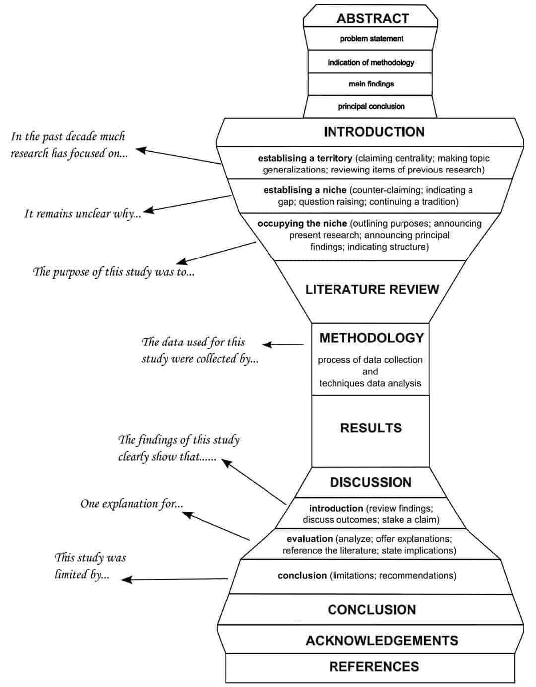

# The parts of your paper

## Checklist

* Cover sheet with the name of the institute, the semester to which your thesis refers, the name of the lecturer, the name of the course and, if applicable, the module, the full title of your thesis, your name, the degree you are aiming for, your subject combination, your matriculation number and the nominal submission date of your thesis;
* Table of contents;
* If applicable, a list of abbreviations and symbols if the work contains individual or non-specialist abbreviations (readers may assume that the abbreviations used are standard and common);
* Main text;
* Bibliography;
* If applicable, a list of figures and tables;
* Appendices, if applicable (all appendices are listed in the table of contents);
* Your declaration, that you have written your thesis independently and that you have faithfully disclosed all the aids and resources you have used in your writing (e.g. through citations or references in footnotes).

## Bibliography

### Citations

There are so many ways to make references and organise a bibliography. You can choose one, but you have to use it consistently. The humanities’ standard in Germany corresponds to Havard’s bibliography and citation system: in your text, you give citations by what librarians call *siglum* ‘scribal abbreviation’. That is only naming the authors’/editors’ second names, the year of their publication, and the page(s) you refer to in brackets (and mainly at the end of a sentence), e.g.: ‘… your text text text (Abbott 2044: 567; Gurpinder/Kim 1956: V, 80–7; Weiyoung et al. 2002: 6–7; Sociologai.lt 2012). Text text text …’

The advantage of sigla is that you can assign an abbreviation to book titles without recognisable authorship or publisher (e.g. encyclopaedias or homepages). For example, you can cite the *Encyclopedia Britannica* from 1906 with the siglum ‘EB 1906’. A Roman numeral indicates the specific volume of multi-volume works. For example, you will receive the citation (EB 1906: XI, 629–31) in your text.

### The style of your bibliography

As far as the individual entry in your bibliography is concerned, make it visually and informatively simple. It is best to consider all parts of the entry as one long sentence. The main title of multi-part works or periodicals should be labelled in italics. Unlike in English-speaking countries, in German-speaking countries, the place of publication is given rather than the publisher itself. However, this is your choice.

First, the bibliography should be organised according to the categories

1. ‘data sources’ (every ‘page’ of any statistical bureau or archive, be it printed or digital) and
2. scholarly literature used/cited by you – to be divided into
   1. ‘printed titles’ including all digital media outlet that has a printed pendant, but both instances share their ISBN/ISSN; and
   2. ‘digital titles’. These mean that there does not exist any printed copy/version of these books/contributions/items anymore (no ISBN/ISSN) but that the item has only digital access (e.g. homepages, blogs, online journals that have a DOI, URN, URL or the like).

Secondly, since you commendably use Havard’s author-year-system in your citations and such a citation is a scribal abbreviation, your bibliography should have a layout that lets the reader recognise the abbreviations.

## Example Bibliography

### Sources

**LatStatis** (2023) = *Oficiālais statistikas portāls – Latvijas oficiālā statistika* [translation of title], URN/URL/DOI: xxxxxxxxx or tiny.url etc.

**LatStatKom** (1990) = 1989. gada vissavienibas tautas skaitisanas rezultati Latvijas PSR [translation of title], Rīga.

**LE** (2023) = *Latvijas Enciklopēdija* [translation of title], online-version of 2023, URN/URL/DOI: xxxxxxxxx or tiny.url etc.

**LRAP** (1991) = Latvijas Republikas Augstākā Padome, ‘Lēmums par Latvijas Republikas iedzīvotāju 1991 g. 3. marta aptaujas rezultātiem’, *Diena* 46=58 (08.03.1991) 2.

**LVAVA** (2003) = Latviešu valodas apguves valsts programma [*later:* aģentūra], Homepage with data archive, URN/URL/DOI: xxxxxxxxx or tiny.url, etc. (Not available anymore, but the author possesses a copy.)

### Printed tiles

**Danto**, Arthur C. (1985), *Narration and Knowledge (including the integral text of Analytical Philosophy of History)*, with an introduction by Lydia Goehr and a conclusion by Frank Ankersmit, New York: Columbia University Press.

**Fleischer**, Michael (1989), *Die sowjetische Semiotik: Theoretische Grundlagen der Moskauer und Tartuer Schule* [Soviet semiotics: theoretical foundations of the Moscow and Tartu schools], Tubingen: Stauffenburg Verlag. (Probleme der Semiotik 9.)

**Forster**, Edward Morgan (1990), *Aspects of the Novel* [1927], ed. by Oliver Stallybrass [1974], London et al.: Penguin Books.

[**Fraj**, Maks] Макс Фрай (2014), *Сказки старого Вильнюса III* [Fairy tales of old Vilnius, vol. 3], Санкт Петербург: Амфора.

—, — (2017), *Сказки старого Вильнюса VI* [Fairy tales of old Vilnius, vol. 6], Москва: АСТ.

—, — (2019 a), *Сказки старого Вильнюса III* [Fairy tales of old Vilnius, vol. 3], Москва: АСТ.

—, — (2019 b), *Сказки старого Вильнюса V* [Fairy tales of old Vilnius, vol. 5], Москва: АСТ.

**Greimas**, Algirdas Julien (1971), *Strukturale Semantik: Methodologische Untersuchungen* [Structural semantics: an attempt at a method], translated by Jens Ihwe, Braunschweig: Vieweg & Son. (Originally French, first published in 1966; English translation published in 1983.)

**Lotman**, Jurij [Юрий М. Лотман] (1977), *The Structure of the Artistic Text*, translated by Gail Lenhoff and Ronald Vroon, Ann Arbor: University of Michigan. (Michigan Slavic contributions 7. Originally Russian, published in 1971.)

[—, —] Юрий М. Лотман (1984), ‘О семиосфере’ [On semiosphere], *Труды по знаковым системам*, 17, pp. 5–23. (Acta et commentationes Universitatis Tartuensis 641.)

—, — [Юрий М. Лотман] (1990), *Universe of the Mind: A Semiotic Theory of Culture*, translated by Ann Shukman, introduction by Umberto Eco, London & New York: Tauris.

[—, —] Юрий М. Лотман (2010), *Семиосфера* [The semiosphere], Sankt-Peterburg: SPB. (Also digitally published in 2012.)

**MacDowell**, James (2014), *Happy Endings in Hollywood Cinema: Cliche, Convention and the Final Couple*, 2nd edn., Edinburgh: Edinburgh University Press.

### Digital tiles

**Ha!art** (2014), ‘Fantomy Europy Środkowo-Wschodniej’ [translation of title], *Kelet* 48:4, URN/URL/DOI: xxxxxxxxx or tiny.url etc.

**Polonskis**, Bartošas (2020), ‘Romanas ›robčikas‹: seksas, narkotikai ir šaltanosiai tuteišiškiai’ [translation of title], *Kalbų vakaras* 13: *Kalbų vakaro kalbos*, S. 13–15, URN/URL/DOI: xxxxxxxxx or tiny.url etc.

**Prie Smetonos** (2022), ‘Kalba tuteišiškai ir tuo didžiuojasi’ [translation of title], *Žinių radijas*, broadcast, 04.04.22, URN/URL/DOI: xxxxxxxxx or tiny.url etc.

[**Rutkowska**, Krystyna] Kristina Rutkovska (2016), ed., *Lietuvos lenkų tarmės* [translation of title], interactive map, URN/URL/DOI: xxxxxxxxx or tiny.url etc.

**Sociologai.lt** (2012) = ‘Vilnietiškoji heteroglosija: Vilniaus lenkų kalbiniai ypatumai šiandien’ [translation of title], anonymous blog post, URN/URL/DOI: xxxxxxxxx or tiny.url etc..

1. Example of footnote.
2. To format a list like this, press Ctrl+Shift+L.